IAM WORKSPACE SETUP USING MICROSOFT

Entra ID

Project Overview

This project demonstrates the initial setup of an Identity and Access Management (IAM) environment using Microsoft Entra ID.

The objective was to create a small enterprise-style identity environment for a fictional organization named Adithya Tech Demo and establish the foundation for future IAM activities such as user lifecycle management, RBAC, access reviews, and privileged access management.

Organization

Organization : Adithya Tech Demo

Identity Platform : Microsoft Entra ID

Cloud Platform : Microsoft Azure

The lab environment was designed to represent a simplified enterprise organization with separate departments and delegated administrative scope.

Objectives

The main objectives of this project were:

- Set up an IAM workspace using Microsoft Entra ID.

- Configure the organization's tenant.

- Create department-based security groups.

- Create test user accounts.

- Assign users to appropriate groups.

- Create an Administrative Unit for the IT HelpDesk.

- Explore custom domain configuration.

- Document the IAM environment for future projects.

IAM Architecture

Adithya Tech Demo

│

▼

Microsoft Entra ID

│

┌─────────────┼─────────────┐

│ │ │

▼ ▼ ▼

Users Groups Administrative Units

│ │ │

┌──┴──┐ ┌──┴──┐ ▼

│ │ │ │ IT Help Desk

▼ ▼ ▼ ▼

HR User IT User HR IT

Security Groups

Two department-based security groups were created:

HR Group

│

└── HR User

IT Group

│

└── IT User

The groups use Assigned membership.

Why use groups?

Groups provide a centralized way to organize users and will later allow access to be managed collectively rather than assigning permissions individually to every user.

This will become particularly useful in the future RBAC project.

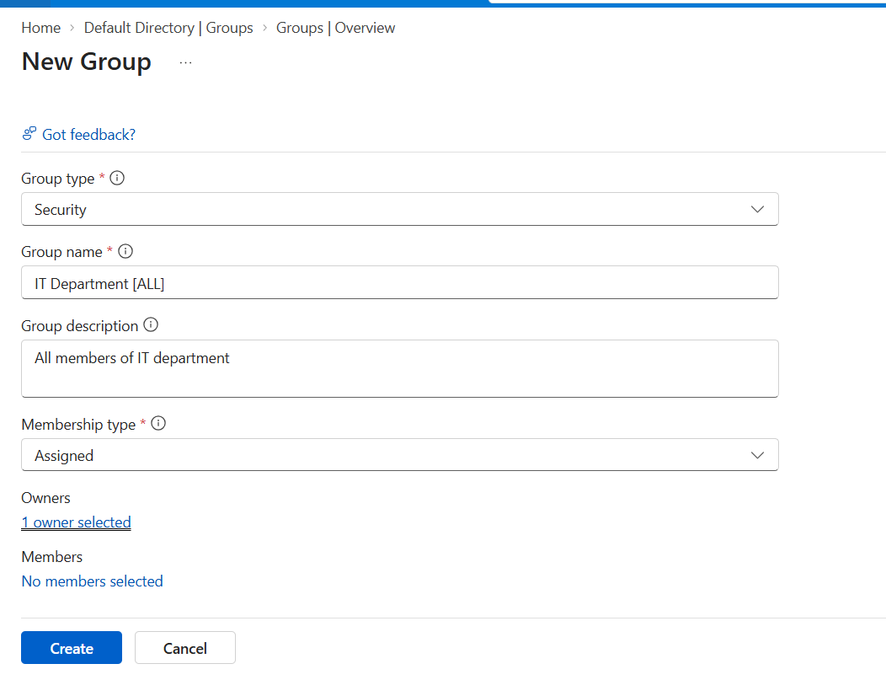
Image 1: Creating IT department security group with membership type “Assigned”
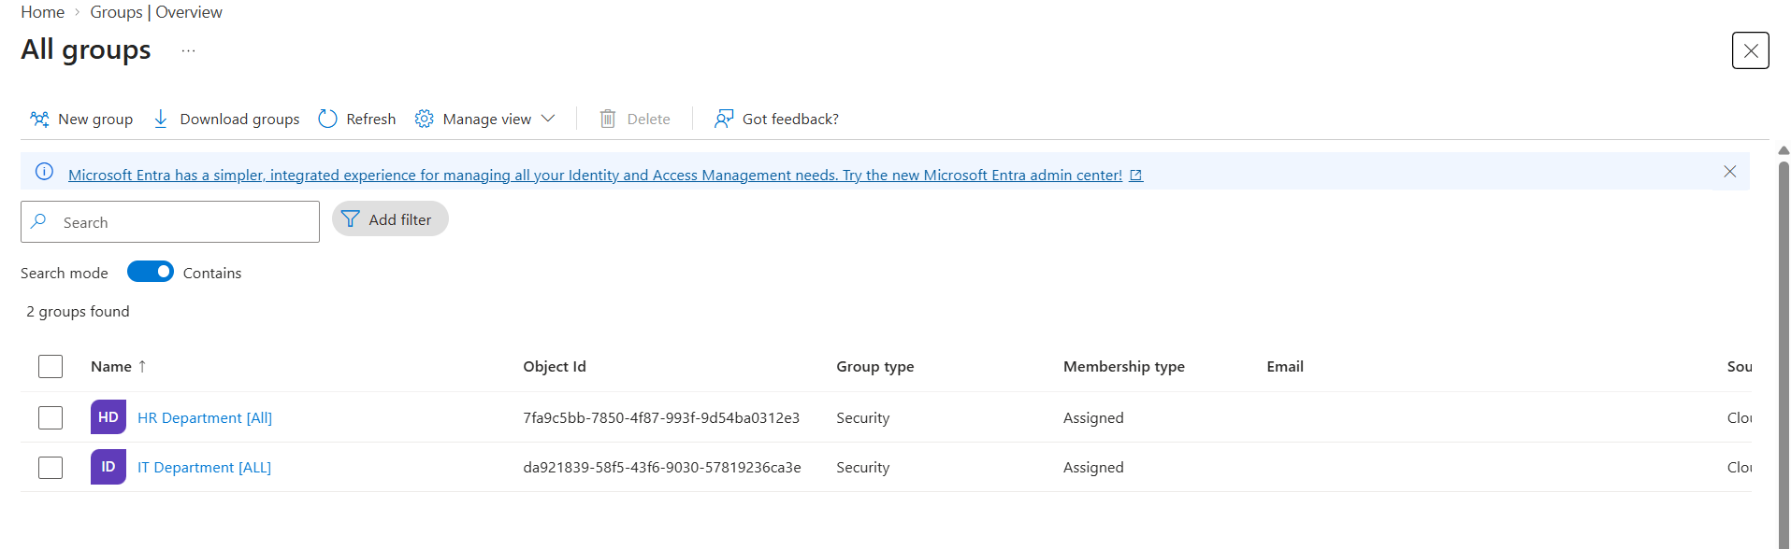
Image 2: All group overview section

User Management
Two test users were created in the Adithya Tech Demo Microsoft Entra ID tenant.
The users were created as internal organizational users using the tenant's default Microsoft-provided domain.

User Structure
User | Department | Group
HR Test User (Adul) | HR | HR Group
IT Test User (Sameekshyo) | IT | IT Group

The purpose of using test users is to simulate a small organization's identity environment without using real employee accounts.
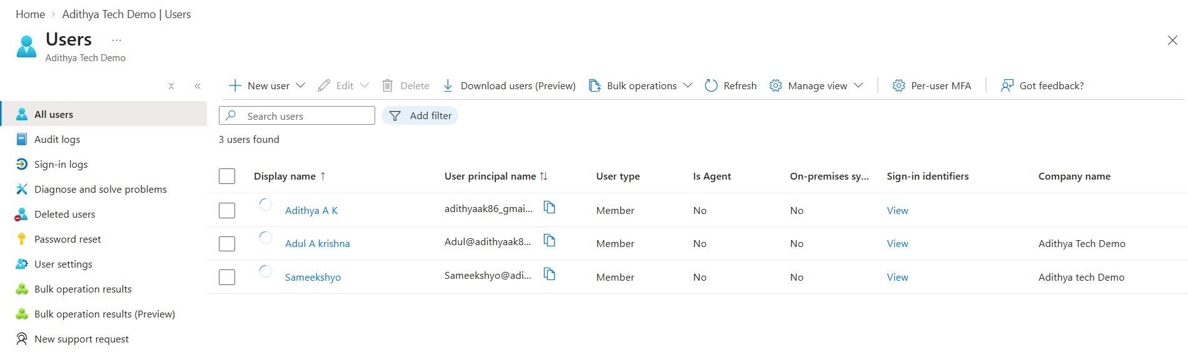
Administrative Unit
An Administrative Unit named:
IT HelpDesk
was created.
Configuration
Name: IT HelpDesk
Description:
IT Support Team members
Restricted Management Administrative Unit: No
Purpose
The Administrative Unit provides an organizational scope for administrative management.
In a larger enterprise environment, Administrative Units can be used to support delegated administration by limiting administrative permissions to a specific organizational scope Microsoft Entra ID Audit Logs were reviewed to verify that identity management operations were successfully recorded. The audit logs captured activities including:
- Add user - Update PasswordProfile - Add member to group
The recorded activities showed a successful status. This demonstrates the use of Microsoft Entra audit logging to track identity-related administrative operations.

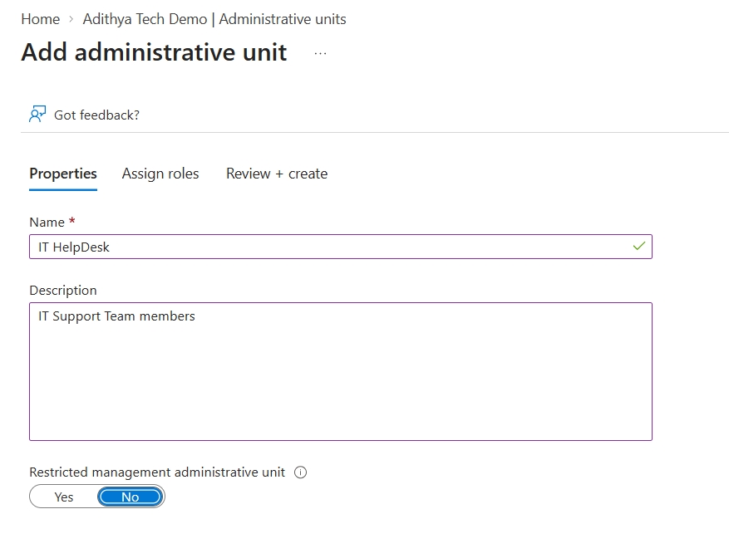🏢
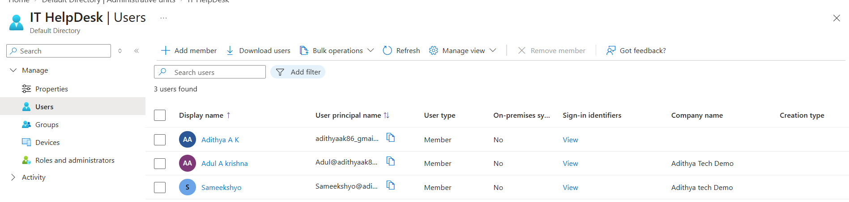

Microsoft Entra ID Audit Logs

Microsoft Entra ID Audit Logs were reviewed to verify that identity management operations were successfully recorded. The audit logs captured activities including:
- Add user
- Update Password Profile
- Add member to group
The recorded activities showed a successful status. This demonstrates the use of Microsoft Entra audit logging to track identity-related administrative operations.
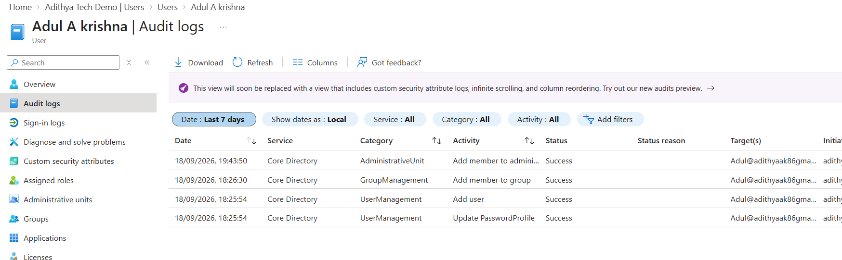
Custom Domain
I also explored configuring a custom domain for the Microsoft Entra ID tenant.
The default tenant domain was available, but the custom-domain configuration was not successfully completed.
For this lab, the default Microsoft-provided onmicrosoft.com domain is sufficient because a custom domain is not required for the IAM exercises.
DNS Concepts Explored
During the domain configuration process, I learned about:
- TXT records — used for domain verification.
- MX records — used to identify mail servers.
- Host/Alias — identifies the DNS name where the record applies.
- Destination/Value — contains the record value.
- TTL (Time To Live) — controls how long DNS information can be cached.
Technologies & Skills
Cloud
- Microsoft Azure
Identity
- Microsoft Entra ID
- Identity & Access Management (IAM)
- User Management
- Group Management
- Administrative Units
- Audit Logs
Other
- DNS Fundamentals
- Domain Verification
- Technical Documentation
- GitHub

📌 Project Status
Status: ✅ Completed
Completed
- Microsoft Entra ID workspace setup
- Organization/tenant configuration
- HR security group
- IT security group
- Test users
- Group membership
- IT HelpDesk Administrative Unit
- Project documentation

